Developing Solar Microgrid Using Matlab

SAI RAM CHANDU DADALA

Electrical and Electronical Engineering Department  
Rajiv Gandi University of Knowledge TechnologiesNuzvid,India  
[n180866@rguktn.ac.in](mailto:n180866@rguktn.ac.in)

*Abstract*— The dependence of human lives on electricity is at its peak. The present conventional central grid consisting integration of regional grids is a vast and complex network involving lot of difficulty to resolve faults and bringing stations back to synchronization even for experts support. Using microgrids we can decentralized central grid concept. A micro grid is a localized and self-sufficient energy system that is capable of generating, distributing, and managing its own electricity. Micro grids can also contain hybrid power generation stations. In this paper we supposed to develop a microgrid to supply a local load of less than 2 kW with solar PV generation as supplying unit. The supply obtained from the pv which is DC is followed by a DC-DC boost converter which is operated to give constant dc output with changing input coming from pv as irradiation and weather changes causes it to give non constant output. The DC-DC boost converter operates with MPPT algorithm of Perturb and Observe method to give constant and maximum power output. The converter then followed with a battery and an inverter. The bidirectional converter allows the flow of power from converter and battery in both directions to store energy during high power generation hours and to use stored energy in the battery during low power generating hours. The inverter which is followed after converter and battery converts dc supply to ac supply with duty cycle of 0.5. The inverter is then followed by a RC filter to obtain sinusoidal output by eliminating higher order harmonics. The filter followed by a transformer to step up the low input voltage to match the high output voltage which ac loads are operated on. The total System is modeled and the wave forms at every level is analyzed with different irradiation levels of PV array using Mat lab 2021.

Keywords—Microgrid, PVgeneration, DC-DCconverters,MPPT, P&O Method

# Introduction

Microgrids with photovoltaic (PV) generation have become increasingly popular in recent years due to their ability to provide reliable and sustainable energy to communities and businesses. The integration of PV generation into microgrids provides a number of benefits, including reducing dependence on the traditional electrical grid, improving energy security, and increasing the penetration of renewable energy.

One of the primary uses of microgrids with PV generation is in remote and rural communities. Many remote communities are not connected to the main electrical grid and rely on expensive and polluting diesel generators for their energy needs. Microgrids with PV generation provide a cleaner and more cost-effective alternative, allowing communities to access reliable and sustainable energy. This has a positive impact on the quality of life for residents and supports economic development by enabling the growth of small businesses and improving access to basic services such as lighting, refrigeration, and communication. In This Research work focuses on the study of Micro grid for the Purpose of distributing energy in an efficiency way within a small range.

# P-V GENERATION

For the assumed 2 kW load, we are using 2kw Solar panel

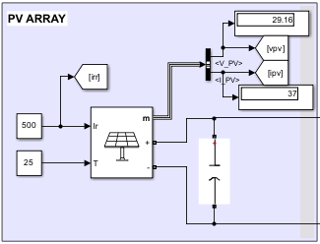

Figure 1. PV array in Mat lab Simulink

PV array consisting 5 parallel strings and 2 series modules capable of producing 2.13 kW at 25 degrees of temperature

# DC – DC Boost Converter

The DC-DC Boost converter which operates with switching frequency as input from the MPPT algorithm which works on maintaining rate of change of power coming from the PV to be zero. The boost converter able to give output of around 24V DC.

## Perturb and Observe MPPT Algorithm

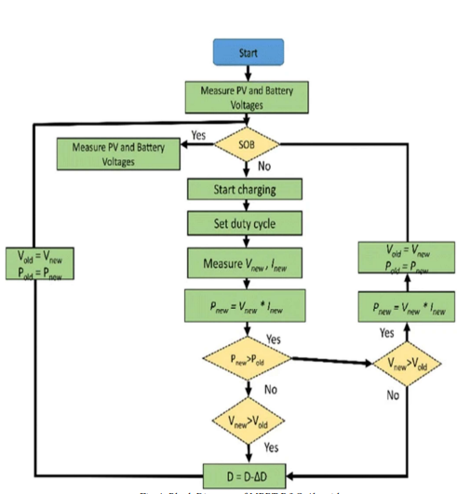

Figure 2. P&O MPPT Algorithm

## The Perturb and Observe (P&O) method is a type of MPPT algorithm. It involves periodically perturbing the operating voltage or current of the solar panels and observing the change in power output, using this information to adjust the operating point to the maximum power point. The P&O method is simple to implement, but its efficiency can be improved by using more advanced MPPT techniques.

# Battery And Bi-Directional Converter

The reference current and the current at boost converter level are compared using a comparator for the switching of the bi-directional converter, which allows the flow of current from the battery and boost converter vice versa. When the current of boost converter is less than the reference current the power is drawn from the battery and when the reference current is less than the current from the boost converter the energy is stored in battery.

# Inverter, Filter and transformer

The inverter converts the dc output coming from the bus where boost converter and battery connected using bidirectional converter. The output at inverter is approximately 50V (Vpp). The inverter switching circuit operated at duty cycle of 0.5 to give the square wave with average value of zero. The RC filter is used to extract the fundamental sinusoidal wave form. Then the circuit followed by a step up transformer to step up the voltage to 230V (Vrms.) which can be fed to the load. Thus the point of Micro Grid.

## Circuit implemented from matlab

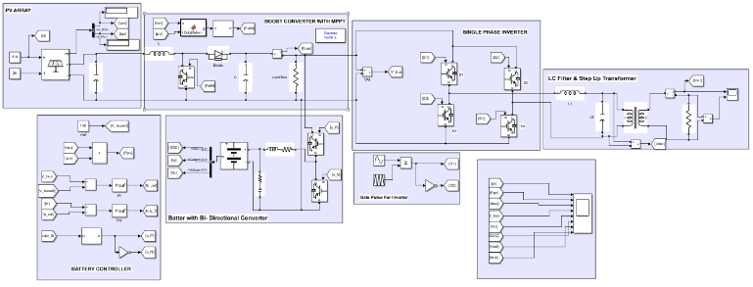

## Pv and Battery Output

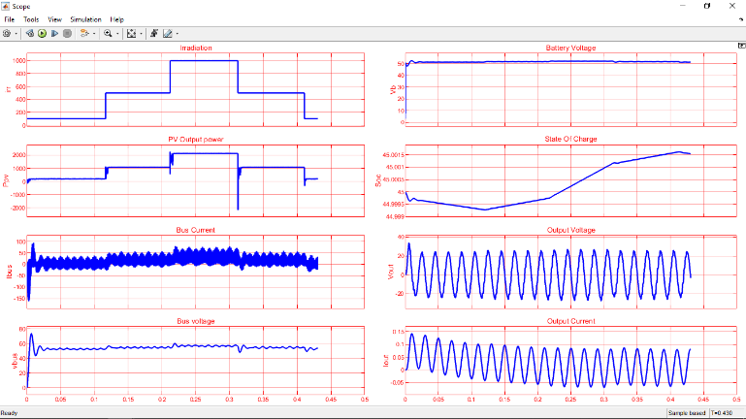

## Inverter Output

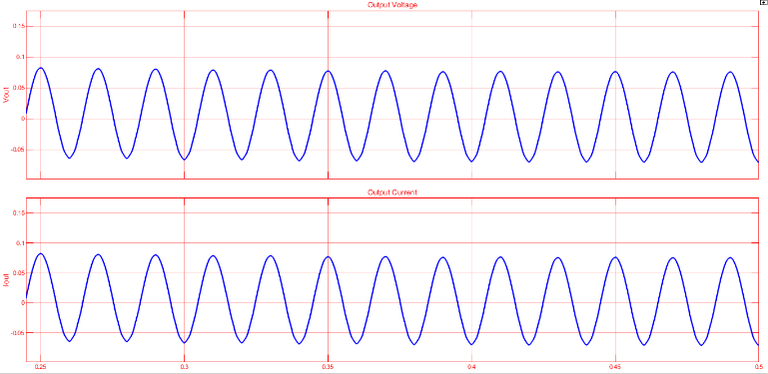

##### Conclusion

We developed a model for a microgrid, and the development process involved making several assumptions to replace practicality issues. The result is a 230 V (VPP) Sinusoidal AC signal that can be fed to a load.

##### References

[1] Aditi & A.K.Pandey, “Performance Analysis of grid connected PV Wind Hybrid Power system,” International Journal of Applied Engineering Research, vol 11,no.1, pp.706-712, (2016).

Modeling and Control of Utility Grid Connected Solar Photovoltaic Array Integrated System Using MATLAB by MAJHRUL ISRAR,ASHOK KUMAR PANDEY ©2017 IEEE

Research on model management method for Micro-grid by CHEN Hong, LENG Hua, TANG Haiguo, ZHU Jiran, GONG Hanyang State Grid Hunan Electric Power Corporation Research Institute Changsha, China and ZHONG Huabing Beijing Tianshi New Energy Technologies CO, Ltd Beijing.China.

"Photovoltaic Systems Engineering" by Roger Messenger and Jerry Ventre

"Power Electronics and Renewable Energy Systems: Proceedings of ICPERES 2014" edited by A. K. S. Bhat, Anupam Shukla, et al.

"Renewable and Efficient Electric Power Systems" by Gilbert M. Masters

"Grid Integration of Wind Energy Conversion Systems" by Siegfried Heier

"Power Electronics: Converters, Applications, and Design" by Ned Mohan, Tore M. Undeland, and William P. Robbins